FEATURES

- Reset Devices on master reset
- 19 reset signals held in reset until written high
- 8bit bus compatible

DESCRIPTION
The HCP65 Device Reset board ensures HCP65 devices are held in a reset state when the master reset signal is set.

The HCP65 GPIO 4bit board is designed to interface with an 8bit microprocessors database

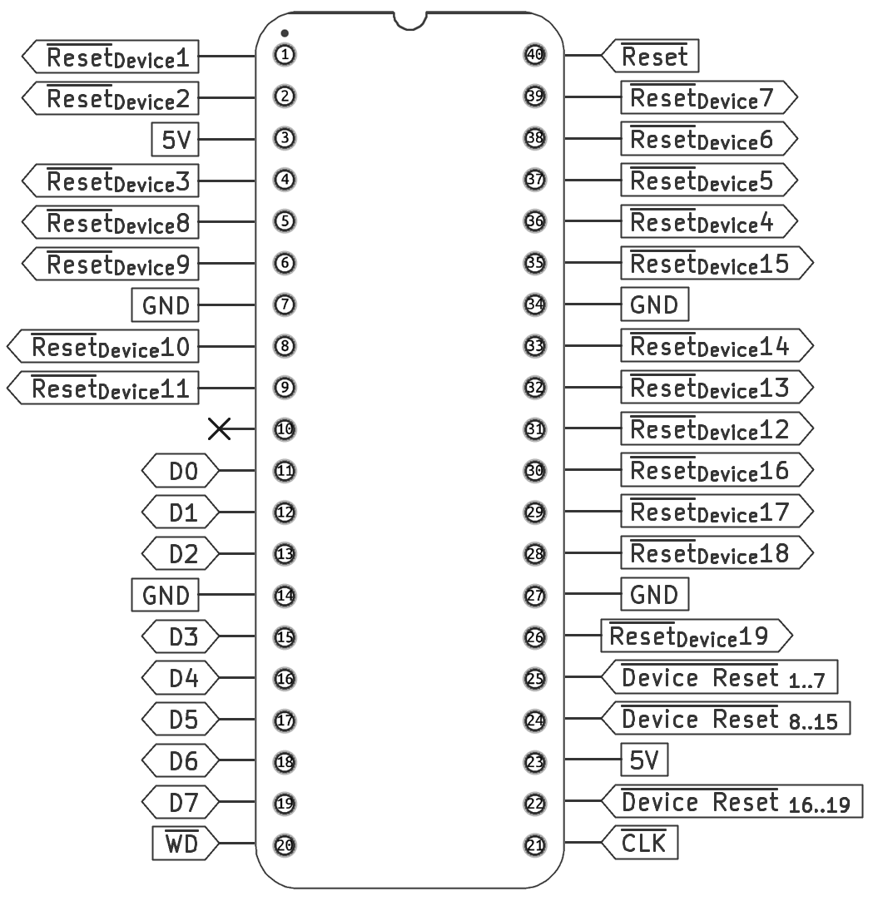

Pin |  | I/O | Function
Name | Number | I/O | Function
5V | 1, 17 | Power
GND | 5, 12, 21, 28 | Power
Read GD | 2 | I | Read from data bus.
Write GD | 3 | I | Write to data bus.
D0  D1 | 14 | IO | Data bus.  Eight data lines with 3-state outputs provide a bidirectional path for data and control of the GPIO board.

FUNCTIONAL BLOCK DIAGRAM

SCHEMATIC DIAGRAM
